**RINGSTEAD PARISH COUNCIL**

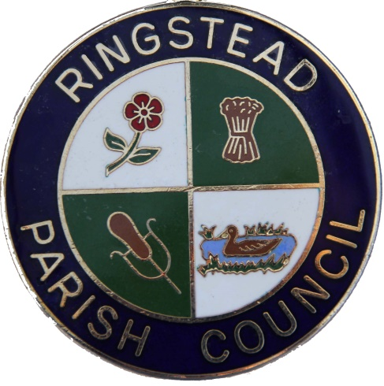

Parish Office: Telephone: 01933 622176

The Village Hall E-mail: clerk@ringsteadpc.org.uk

9 High Street Web: www.ringsteadpc.org.uk

Ringstead

Northants NN14 4DA

**Minutes** of the **Meeting** of Finance Advisory Committee

held on Weds 4th Sept 2024 at 1830 hrs

04.09.2024

Present: Cllr G Slack Cllr I Grant Cllr T Knight

In Attendance: Ms L Ritchie (Clerk to the Council)

|  |  |  |
| --- | --- | --- |
|  |  | **Action** |
| **RPC_FAC499**  **RPC_FAC/500**  **RPC_FAC/501**  **RPC_FAC/502**  **RPC_FAC/503**  **RPC_FAC/504**  **RPC_FAC/505** | **Public Open Time (Members of the public are invited to address the Council, give their views and question the Council on issues on this agenda, or raise issues for future consideration (at the discretion of the Chairman). Members of the public may not take part in the Council meeting itself. At the close of this item members of the public will no longer be permitted to address the Council unless invited to do so by the Chairman. The session will last for a maximum of 15 minutes with any individual contribution lasting a maximum of 3 minutes. Members of the public should address their representations through the Chairman of the meeting).**  **RESOLVED** No members of the public in attendance.  **To Receive and approve apologies for absence.**  **RESOLVED** No apologies received.  **To receive Declarations of Interest under the Council’s Code of Conduct related to business on the agenda. (Members should disclose any interests in the business to be discussed and are reminded that the disclosure of a Disclosable Pecuniary Interest will require that the member withdraws from the meeting room during the transaction of that item of business. Declarations must be made verbally at the appropriate time as well as entered in the Interest Book).**  **RESOLVED DOI from TK in respect of salary payment, RP also asked that TK checks if he has reached tax threshold for paye, Clerk and TK to investigate.**  **Previous minutes/actions.**  **RESOLVED** Previous minutes approved, to be published.  **Spot Checks (invoices/payments etc.)**  **RESOLVED –** Spot checks carried out Valda Energy still showing as TBC on August appendix A, and invoice has come through for September meeting, they have been going back over old Invoices and adjusting the vat rate, hence the low Invoice.  **Approve Submitted Invoices**  **RESOLVED-** .Invoice from F P Roofing services for £5,500 approved for payment.  **Budget** No Concerns over budget so far, current expenditure stands at £41,598, Income £88,2228 and total revenue of £168,423  Village hall income is lower than expected, Clerk confirmed both Scouts and art group are due to pay bulk payment, in Oct 2024.  **Close**. Meeting closed at 1843 hrs.  **Date of next meeting Weds 2nd Oct 2024.** |  |
| Signed  Print  Date |  |  |